Have a safe journey,
Mr. Waste!
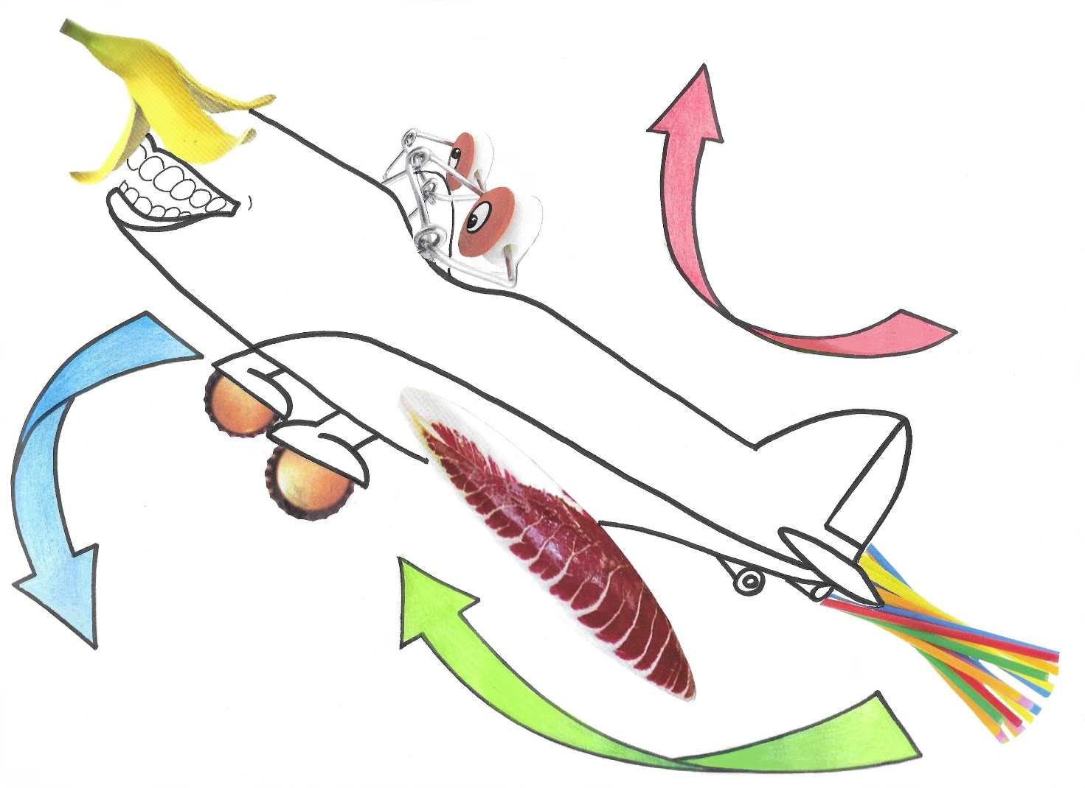



“The Journey of Mr Waste”

